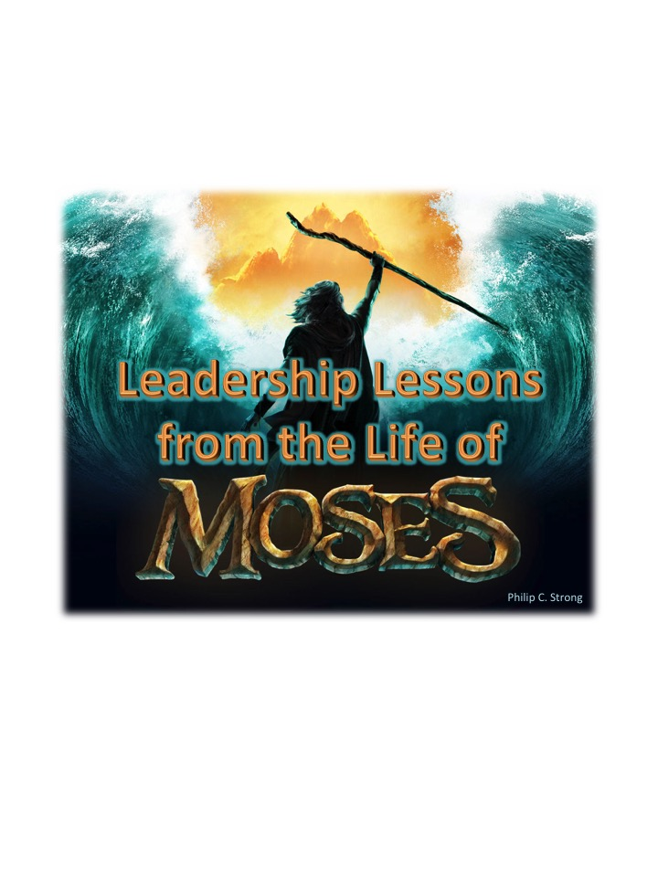
Leadership Lessons from the Life of Moses, Volume I
Table of Contents
Lesson

1. Preparation of Mind- Education is Important, Ex.2:1-10
2. Preparation of Heart- Having Compassion for Those to be Led, Ex.2:11-13
3. Preparation of Life- Commitment and Hard Choices are Required, Heb.11:24-27
4. Preparation of Relations- From, In, and Through Family, Ex.2:16-22; 4:24-30
5. Preparation of Power and Purpose- Allied with God for His Purposes, Ex.3:4 - 4:10
6. Preparation of Support- Get the Family On Board, Ex.4:18-20,27-30
7. God Doesn’t Accept Excuses, But Provides Ways, Ex.4:10-17
8. You Don’t Have to Always Understand “Why?” Ex.4:21-23
9. Leadership Doesn’t Excuse You from Family Responsibilities, Ex.4:24-26
10. Make God’s Precepts and Plan Plain-
Involve Those To Be Led in the Process, Ex.4:29-31
11. Try the “Easy Way” First, Ex.5:1-3
12. There Will be “Pushback,” Ex.5:4-9
13. It May Get Worse Before It Gets Better-
Initially, You May Have to Work Harder, Ex.5:10-19
14. Those To Be Led May Not Always See “the Big Picture,” Ex.5:20-21
15. It’s OK to be Discouraged and Cry Out to the Lord… Ex.5:22-23
16. But He Will Remind You of His Time, Plan, Promises, and Power, Ex.6:1-8
17. Some Can’t See the Light at the End for the Darkness of the Tunnel, Ex.6:9
18. God Doesn’t Accept Excuses-
Especially from Those He has Prepared and Appointed, Ex.6:10-13,30
19. Be Courageous and Speak All That God Commands-
It’s Why He Put You in Leadership, Ex.6:29; 7:2
20. Remember that God’s Means Are Justified by His Ends, Ex.7:3
21. Leadership Won’t Be Easy, and It May Get Nasty and Stinky,
but Trust and Obey- God’s Got This! Ex.7:6-21
*Please understand that this is a study of “Leadership Lessons from the Life of Moses” rather than a textual study of the book of Exodus. As such, sections of the text that do not pertain directly to our purpose will not be covered. All scripture quotations, unless otherwise noted, are from the NASB, 1971.
Leadership Lessons from the Life of Moses, Introduction
It could be argued that God appointed every man from Adam onward as a “leader” of his family- should he be so blessed, as well as putting him over “the fish of the seas and over the birds of the sky and over the cattle and over all the earth, and over every creeping thing that creeps on the earth,” Gen.1:26b. And certainly, Abraham was specifically chosen by God “that he may command his children and his household after him to keep the way of the Lord by doing righteousness and justice; in order that the Lord may bring upon Abraham what he has spoken about him,” Gen.18:19. But in some senses, Moses was the first man God appointed to the spiritual leadership of other men- those not directly related to him, and it was an entire nation no less!
Thus, it seems fitting to give due consideration to the lessons to be learned regarding “leadership” from God’s first appointed, prepared, and dedicated leader, Moses. In these lessons we will be noting principles of leadership that can (and I think should) be gleaned from several avenues: the commands/instructions of God to Moses; the dedication and devotion of Moses to his appointed task; and his interactions with the people he led, and theirs with him. And since negative lessons and unsuccessful examples can be as instructive as the positive and successful ones, we will also consider his interactions with those who refused and rebelled against his leadership.
The Essence of Leadership
In the absence of inspiration- and there seems to be no direct evidence or indication of it, Jethro was indeed a wise Midianite. Moses’ father-in-law, in some ways at least, encapsulated the essence of spiritual leadership in Ex.18:13-23 as being made up of:
- Fellowship with God, v.19a;
- Mediation for the people of God, v.19b;
- Education in the statutes and laws of God, v.20a;
- Interpretation and Instruction to Application, v.20b;
- Division of Labor, v.20c; and,
- Provision for additional (present or future) leadership, v.21.
And Moses, as all good leaders do, listened to and followed wise counsel, v.24!
Indeed, Moses was a man like no other in all of Scripture. God said things about him that were not and can not be said of any other individual in the Old or New Testaments, cf. Num.12:1-8a.
But have you considered how and when Moses became such a great prophet and leader of God’s people?
For the first third (40 years) of his life, Moses was educated in all the learning and wisdom of the Egyptians- the best education Pharaoh’s money and power could procure. Though God’s people were already enslaved, and were being badly abused, this education hadn’t fully prepared him to be God’s spokesman and Israel’s deliverer, Ex.2:10; Acts 7:22-28.
It wasn’t until he spent another third (again, 40 years) raising a family and tending sheep that God called to him from the burning bush and commissioned him to be the prophet and leader we remember, Ex.3:1-10; Acts 7:29-34.
Then, and only then, was he adequately prepared to spend the last third (yep, another 40 years) speaking for God and leading His people, Acts 7:35-38!
Are there lessons to be learned from these things for God’s spokesmen, Shepherds, and leaders of His flock today? Absotively and posilutely! In the lessons that follow, we’ll attempt to highlight some of them to the glory of God and the benefit of His purposes through and for His people today.
Leadership Lessons from the Life of Moses
Introduction Discussion Questions

- In what way was Moses’ leadership role different from anyone before him?
- From what 3 avenues will this study be deriving principles of leadership from the life of Moses?
- Jethro (Moses’ father-in-law) summarized spiritual leadership in Ex.18:13-23. Please describe how or why you think each of the principles he provided is important to one’s ability to lead:
  - Fellowship with God, v.19a.
  - Mediation for the People of God, v.19b.
  - Education in the Statutes and Laws of God, v.20a.
  - Interpretation and Instruction to Application of God’s Law, v.20b.
  - Division of Labor, v.20c.
  - Provision for Additional (present or future) Leadership, v.21.
- How did Moses respond to Jethro’s wise counsel?
- At what point of Moses’ life did God decide he was ready to lead the Israelites out of Egypt? What is the lesson for us in this?

